## 

## Description

The purpose of this document is to describe the Umbrella: Weather website, its purpose and intended audience, utilization scenarios, and other aspects such as its organization and structure, elements of style, etc. It is to be used as a planning and elaboration tool for the personal site to be developed this semester as part of the CIT 230-07 course.

## Site Name

Umbrella: Weather is the name of the site, with the domain being: **umbrella-weather.com**. The name and logo display the main purpose of an umbrella which is to protect from unforeseen events related to weather and climate.

## Purpose Statement

The main purpose of the website is to provide accurate and quick information to educate and inform users about weather conditions so that they can make better decisions related to their daily activities, hobbies, events, etc.

## Target Audience

The target audience includes a great variety of profiles, from people just trying to see the weather for curiosity, to individuals that depend on the weather to accomplish tasks and succeed in their day-to-day activities.

**Who:** Outdoor enthusiasts, householders, teenagers, drivers, commuters, event coordinator,   
**Age:** 13 – 90+  
**Work status:** People that work outside such as tour guides, law officers, sport coaches or refs, motorcycle drivers (delivery), any other employee that has to commute.  
**Motivation:** To be aware of weather conditions and make appropriate decisions to increase success in daily plans and tasks.

## Personas

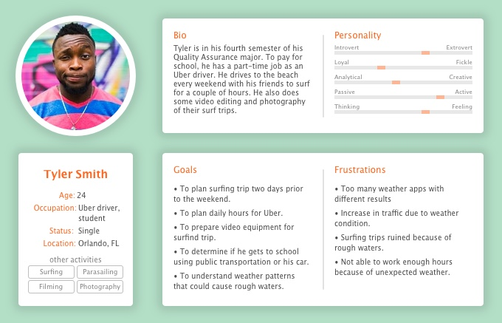

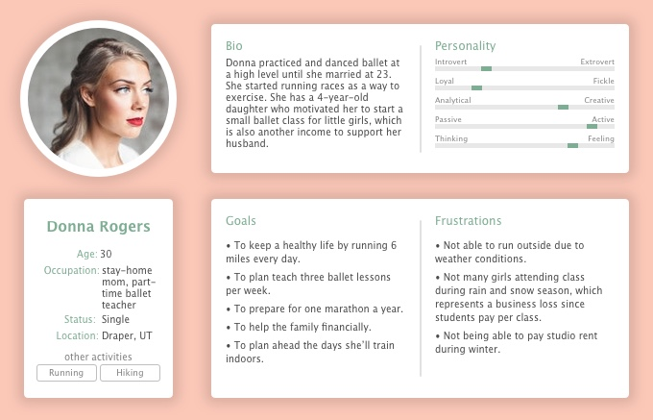

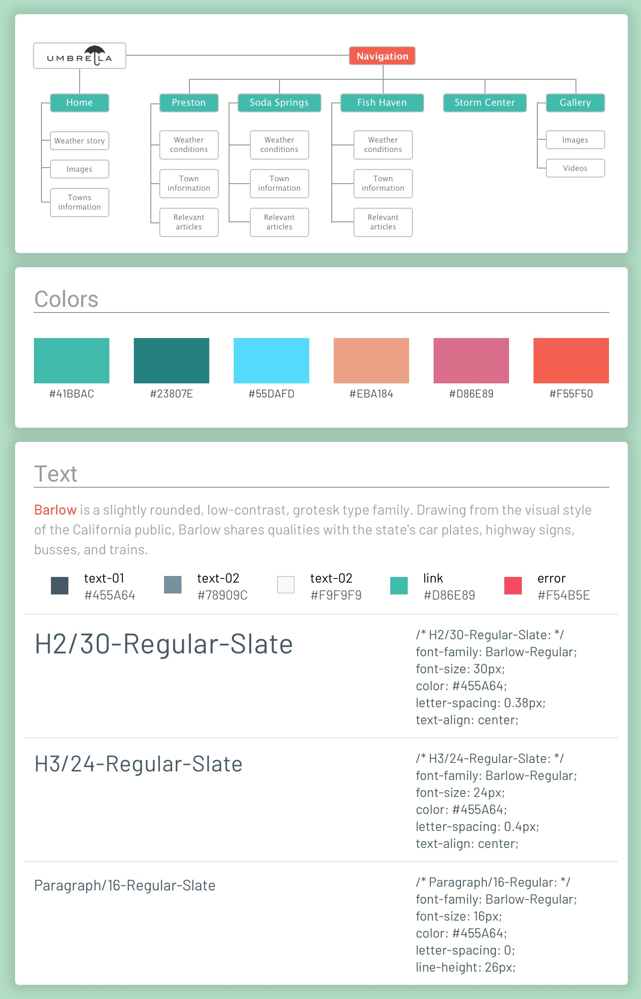

## Mobile Wireframes

